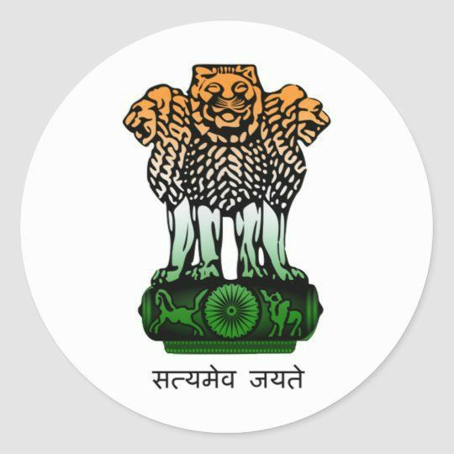 **Government of India** 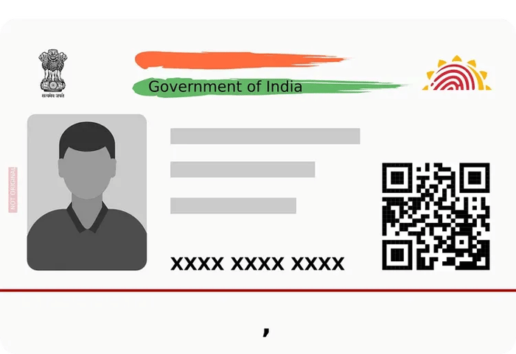

**Shiv Mohan**

**DOB: 30/07/2008**

**MALE**

**9988 0099 0998 8877**

**VID : 6655 5566 3345 2345**

**MERA AADHAR MERI PECHAN**